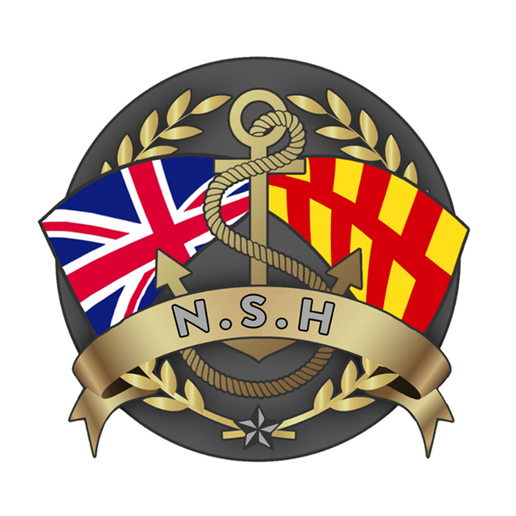

North Sunderland Harbour

Safety Management System

Section 10 – Marine Accident Investigation Procedure

Harbour Authority Investigations

- The Guide to Good Practice states in paragraph 13.7 “Harbour authorities have a responsibility to investigate marine incidents in harbour waters and the Safety Management System should contain clear procedures on the levels and purposes of accident investigations that will be expected of a harbour authority. Those procedures should also identify who will be responsible for carrying out the investigations.”

Purpose of Marine Incident Investigations

- Paragraph 13.8 also states “A harbour authority’s Safety Management System should carry clear procedures to be adopted with respect to accident investigation. Those procedures should provide clear indicators to the authority’s officers on how to determine, at an early stage, the purpose of the investigation. It is to be noted that the investigations of marine incidents have two essential purposes:

  - To determine the cause of the incident, with a view to preventing a recurrence of that incident (or similar); and

  - To determine if an offence has been committed: if so, there may be the need, on the part of the organisation, to initiate enforcement action that may lead to prosecution in their own right.”

Reporting

- All incidents whether ashore or afloat should be reported to the North Sunderland Harbour Master.

- The Harbour Master will gather sufficient information to be able to use the GTGP flowchart (Page 147) and as shown below to establish the next steps.

- Where appropriate, marine incidents are reported to the MAIB in line with the Merchant Shipping (Accident Reporting and Investigation) Regulations 2012. Guidance on reporting under these regulations is given in Marine Guidance Note (MGN) 458.

- Where appropriate, incidents that take place ashore are reported to North Sunderland District Council. They will then report the incident to the HSE in line with HSE Work Instruction 0011 – Accident Reporting.

Incident Investigation

- The Harbour Master will take into consideration the following factors in deciding if a Formal Investigation is required:

  - The seriousness of the incident
  - The possible outcomes that could have arisen from the incident i.e. if it was a near miss.
  - Whether or not it was a reportable incident.
  - Any recurring trends highlighted by the incident.

- The Harbour Master will appoint suitably qualified & competent persons to be carry out the investigation. They will be independent of any involvement in the incident itself and dependant on who was involved in the incident and the nature of the incident, it may be decided that external resources need to be called upon to carry out the investigation.

- Should the investigation be to determine if an offence has been committed, the involvement of a prosecuting authority such as Police, MCA or HSE may require “primacy” to be established as to which organisation takes the lead role. Should it be decided that a criminal offence has taken place, any interviews will be required to comply with the Police and Criminal Evidence Act 1984 (PACE).

Formal Incident Investigation Terms of Reference

- The Harbour Master will assign the investigation with the following Terms of Reference for the report and a deadline for production of the report.
  - Introduction.
  - Comprehensive narrative of events.
  - Statements from all persons involved.
  - Copies of communications and documents.
  - Record of damage caused to Port structures and property.
  - Record of damage to third party property.
  - Record of any pollution.
  - Recommendations for changes to Port procedures to prevent a similar incident occurring in the future.

Incidents Causing Pollution to the Harbour

- Where the incident involves pollution of the Harbour marine environment, the appropriate action will be taken as detailed in the Marine Pollution Response Plan. A Polrep CG77 Report will be completed and forwarded to the MCA.

MAIB Safety Digest

- The MAIB Safety Digest will be circulated, read and acknowledged by the Harbour Master and his deputies. Reported incidents occurring elsewhere will be considered to determine if lessons can be learnt and if procedures in North Sunderland Harbour need to be reviewed as a result.

Marine Incident Investigation –Flow Chart

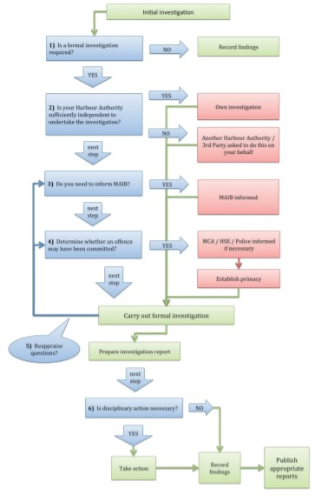
Figure 1 - GTGP Incident Investigation Flowchart

