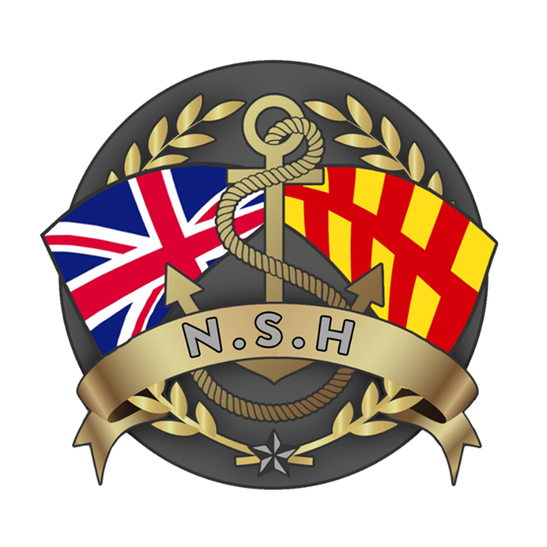
North Sunderland Harbour

Safety Management System

Section 11 – Diving

Introduction

The purpose of this guide is to ensure a regulatory compliant and a safe system of work is followed for any Diving operations that might be undertaken within North Sunderland Harbour.

1.1 The Diving at Work Regulations 1997 and MGN424 place responsibility on Harbour Authorities (HA's), Diving Contractors and Clients.

1.2 The Regulations detail in particular the responsibilities of the diving contractor, diving supervisor and the Master and Crew when carrying out commercial diving operations. They also detail the role of the Harbour Authority placing a general responsibility on Harbour Masters to take reasonable steps to ensure that commercial diving operations within the harbour area are undertaken safely and in accordance with the Regulations.

Harbour Authorities may be involved in commercial diving operations in various ways, including:

- HA's within whose area of responsibility diving projects are undertaken.

- HA's that are Clients and engage a Diving Contractor to undertake a diving project.

1.3 These instructions are issued to ensure that all underwater operations strictly comply with the above Regulations and any additional procedural requirements of North Sunderland Harbour.

2. Responsibilities

All diving operations arranged for or on behalf of North Sunderland Harbour must:

- Be properly authorised.
- Be carried out only by Diving Companies approved by the Board.
- Comply strictly with all current legislative requirements.

The Harbour Master is responsible for:
- Authorising diving operations.
- Approving diving companies to carry out work in the Port;
- Consulting with those concerned in any diving operation and then issuing in writing any specific requirements / instructions;
- Ensuring that diving operations are carried out in compliance with the requirements of North Sunderland Harbours;
- Maintaining full records of all authorisations and any other matters relating to the safe undertaking of any diving operation.
- Issuing a Local Notice to Mariners advising of any diving operations within the Ports jurisdiction.
- Ensuring the diving platform conforms to the appropriate code of conduct.
- Dealing with any emergency situation.

The Diving Contractor is responsible for:

- The workboat or vessel must show the diving flat, (International Code A rigid), which must be clearly visible and illuminated if necessary.
- The diving project is properly and safely managed.
- Risk assessments have been carried out.
- The place from which the diving is to be carried out is suitable and safe.
- A suitable diving project plan is prepared which includes emergency and contingency plans.
- The supervisor and dive team are fully briefed on the diving operation that will be involved with and aware of the contents of the overall diving project plan.
- The personnel are competent and/or qualified.
- Supervisors are appointed in writing and the extent of their control documented.
- Adequate arrangements exist for first aid and medical treatment.
- Suitable and sufficient plant is provided and maintained.
- The team is medically fit to dive.
- Diving project records are kept containing the required details of the dive.
- A clear reporting and responsibility structure is laid down in writing.
- All other relevant regulations are complied with.

The Master of the Vessel is responsible for:
- Not authorising the commencement of diving operations until they are satisfied that the required control measures have been taken and all key ship’s personnel, such as the Chief Engineer, have been informed.
- Making the crew aware of what machinery/systems not to operate during the dive operation, the systems in place to prevent operation of these machinery/systems and the procedures required if they are required in an emergency situation.
- Establishing agreed means of communication with the diving supervisor and advise on matters considered relevant during the diving operation (e.g. changes in sea condition, surface visibility etc.).
- Preventing the occurrence of activities that may endanger those involved in the diving project. Where necessary notices should be posted on machinery vital to the diving project to prevent it inadvertently being stopped or started.

Approval Process for a Diving Operation

- Before commencing work, a written approval to dive must be given by the Harbour Master. The request should include the following information:

- Name of Diving Contractor.
- Name of Diving Supervisor.
- Reasons for the Diving Work.
- Exact Diving position, to include plan of dive area unless diving in a single location.
- The date and time Diving will commence.
- Estimated time of completion of the Dive.
- Name of Diving Support craft or position from which Divers will be deployed.
- Any additional risk identified that requires special precautions by North Sunderland Harbour.

- The Harbour Master will make sure that a current Notice to Mariners is in force to cover the diving operations being carried out.
- The Harbour Master will grant or refuse permission and advise the applicant by signing and then emailing the form back to the originator. This will include any particular information or instructions that the HM considers relevant or useful to the Diving Contractor/Supervisor.
- The approval to dive form will be saved by North Sunderland Harbour for a period of 3 years.

Live Diving Operations

- When arriving on site the diving supervisor is to contact & confirm with HM that the dive is to take place and request an update on any information, which may be relevant to the dive. In particular, vessel movements.

- From this time onwards, the diving supervisor will keep in constant communication with HM on VHF Channel 08 for the following purposes:
- To advise when divers are being sent into the water and to advise when divers are clear of the water.
- To be prepared to move with the divers (and boat if employed) to a place of safety if instructed by North Sunderland Harbour HM.
- To warn North Sunderland Harbour HM immediately of any difficulties encountered which would delay the divers (and or boat if employed) moving to a safe place, giving an approximate length of time required to move.
- To advise immediately when it is clear for vessels to enter/leave the diving area.

- When the divers are to work in close proximity with ship's hulls, the diving supervisor is to confirm with the 'Client' that all propellers, azipods, bow thrusts and waterjets must not be operated. Main inlets are closed and an officer will place a notice on the vessel's starting panel/and all operating controls warning that divers are working under their vessel.

- Particular care must be taken when divers are to work in those areas to which the general public has access for fishing or other sporting activity. For all work in these areas, the area will need to be closed to such activities for the duration of the setting up and actual dive.

- If an accident or emergency situation occurs to the diver(s) whilst they are in the water, North Sunderland Harbour HM is to be informed immediately who will use their best endeavours to arrange assistance. All such messages must be prefixed with "Diving Emergency - Urgent".

