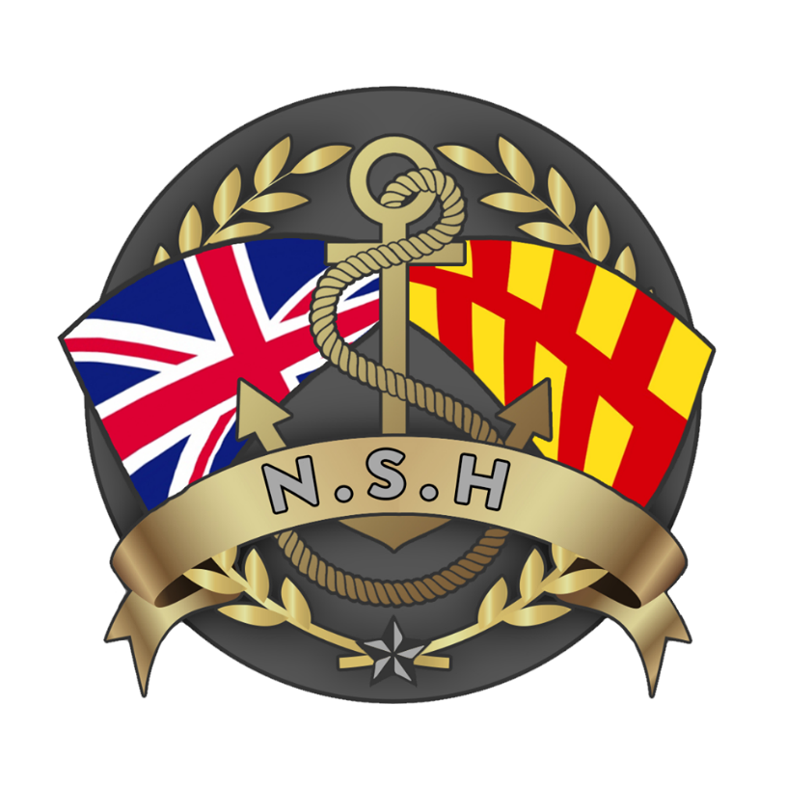

North Sunderland Harbour

Safety Management System

Section 12 – Harbour Users Group
Terms of Reference

- North Sunderland Harbour Commissioners have established a group, to be known as the Harbour Users Group (HUG). The North Sunderland Harbour Commissioners Harbour Master will regularly consult with the HUG on all matters substantially affecting the conservation, protection, regulation, management, maintenance and improvement of North Sunderland Harbour and its navigation.

- Purpose – to allow Harbour Stakeholders to have a vehicle to express their opinions in the affairs of North Sunderland Harbour.

- The HUG shall consist of 10 representatives invited from the following organisations and harbour interest groups, members active form 2025 are shown in red below:

  - One North Sunderland Harbour Parish Councillor shall be appointed, nominated by North Sunderland Parish Council or by a member of the HUG. Ms Ailsa Shiel.

  - Two shall represent commercial fishermen based and operating out of North Sunderland Harbour, nominated by the fishermen or by a member of the HUG. Mr David Fordy / Mr Asa Howe

  - Two shall represent tripping boats based and operating out of North Sunderland Harbour nominated by the tripping boats or by a member of the HUG. Mr William Shiel / Mr Andrew Douglas.

  - One to represent Fluke Hole Marine Club. Mr John Thorburn.

  - One to represent the North Sunderland Harbour leisure users and diving operators. To Be Nominated.

  - One to represent the RNLI. Mr Hugh Fell.

  - One to represent the National Trust. To be Nominated

  - 2 x shop business proprietor / hotelier / B&B / Caravan park owner.
Mr Michael Dawson as Chair / Ms Kerry Burrow.

- The HUG will meet twice a year as a minimum, their meetings being interspersed with those of the North Sunderland Harbour Commissioners, who normally meet every 2 months.

- If the HUG does not receive a nomination for any reason from any of the organisations mentioned in Clause 3 a.to i. above, the HUG may, after consulting with other organisations it thinks appropriate, appoint a suitable alternative or none at all.

- This procedure will also be followed should any of the organisations mentioned in Clause 3 a. to i. above cease to exist or the function of the organisation changes significantly.

- The HUG shall not be obliged to appoint a person who is duly nominated in accordance with any of sub-paragraphs 3 a. to i. above but may request the body or bodies who made the nomination to nominate another person.

- The term of office of a member of the HUG shall be three years from the date of his/her appointment and, on ceasing to hold office, he/she shall be eligible for re-appointment for a further 3 years only: provided that a member of HUG may at any time, by notice in writing to the North Sunderland Harbour Commissioners, resign his/her office.

- The HUG may determine its own quorum and procedures.

- The HUG shall nominate its own Chairperson. Chair to be re-elected no less than every 3 years.

- Without prejudice to paragraph (1.) above, the North Sunderland Harbour Commissioners shall seek the views of the HUG on:

  - North Sunderland Harbour Commissioners Management and Business Plan.
  - Proposals to vary any charges in relation to business and recreational use of the harbour and its use by any vessels.
  - The making of byelaws, directions or revision orders.
  - Proposals to construct or license any significant works in the harbour including dredging.
  - Changes to the use of the harbour.

- The North Sunderland Harbour Commissioners shall take into consideration any matter, recommendation or representation which may from time to time be referred or made to them by the HUG, whether or not it has been consulted by the North Sunderland Harbour Commissioners on the matter, recommendation or representation so referred or made.

- Any nominated member that misses two consecutive meetings shall be removed from the group and the nominating body will be asked to nominate a new representative.

- Members may nominate a substitute to attend the HUG meetings.

- An agenda and record of minutes of each meeting is to be produced.

- The North Sunderland Harbour Master (or substitute representative) will attend HUG meetings to observe and advise but will have no voting rights. Any serving Harbour Commissioner may attend as observers if required.

- These Terms of Reference to be reviewed every 3 years.

