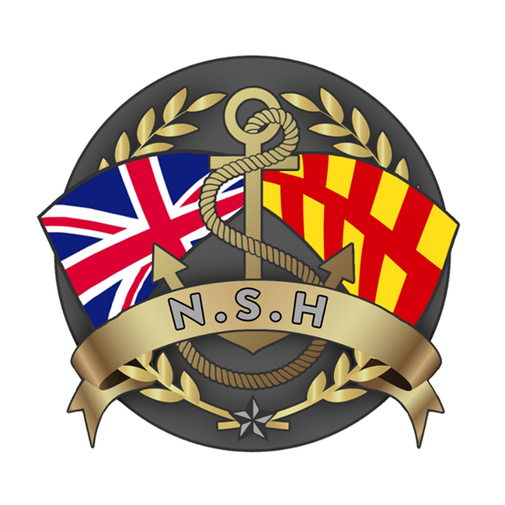
North Sunderland Harbour

Safety Management System

Section 14 – Edge Protection

Introduction

- A harbour authority is obliged to take reasonably practicable measures to ensure the safety of those who visit and use the harbour (Section 3 Health and Safety at Work Act 1974).

- Many activities carried out in ports and harbours could lead to a fall from height (the biggest cause of work-related fatalities and major injuries). In docks, the added hazard of working near water means that a fall may lead to the risk of drowning.

Typical falls from height hazards in docks include:
- Access to and from vessels;
- Loading and unloading some types of cargo;
- Maintenance and unplanned work on or near the water’s edge;
- Working adjacent to open edges of docks, wharves etc; and mooring points.

- This policy sets out North Sunderland Harbour Authority’s approach to edge protection and our obligations under Health and Safety regulations.

Regulation

- Legislation which covers the need for edge protection includes:

- Health & Safety at Work Act 1974.
- Management of Health & Safety at Work Regulations 1999.
- Work at Height Regulations 2005.
- Merchant Shipping (means of access) Regulations 1988.
- The Construction (Health, Safety & Welfare) Regulations 1996.
- Provision & Use of Work Equipment Regulations 1998.
- Lifting Operations & Lifting Equipment Regulations 1998.
- Personal Protective Equipment at Work Regulations 1992.
- Manual Handling Operations Regulations 1992.
- Shipbuilding & Ship Repairing Regulations 1960.
- Health & Safety in Construction HS-G 150.
- HSE Safety in Docks - Approved Code of Practice and guidance (April 2014).
- Code of Practice on safety and health in ports (ILO152).

- Guidance on edge protection is set out in sections 150 - 153 of the HSE’s Safety in Docks - Approved Code of Practice (ACOP) dated 2014:

  - 150: Except for straight and level quaysides, fencing should be provided at all dock, wharf, quay or jetty edges from which people may fall into water, and where they must pass within 1 m of the edge, or the configuration of the quay or the arrangement of walkways is such that they are more than ordinarily liable to fall over such an edge.

  - 151: Fencing should be provided throughout every open side of narrow access ways, whether the fall would be into water or not.

  - 152: These provisions do not apply to areas where there is no work activity being undertaken, subject to any foreseeable risk to members of the public.

  - 153: Secure and adequate fencing should be provided where risk assessment has found this to be needed.

Edge Protection Risk Assessment

- North Sunderland Harbour Authority has determined, through risk assessment, that the need for edge protection control measures to reduce the risk of falling from height is As Low As Reasonably Practicable (ALARP).

- It has determined the need for fencing or other control measures by employing the following principles:

  - HSE advise that harbour authorities need to consider whether the open sections are used for ‘fishing’ or ‘dock’, type operations, such as specific loading/unloading tasks. In areas where loading or dock processes are going on, the Loading and Unloading of Fishing Vessels Regulations 1988 and the HSE Safety in Docks – ACOP 2014 recognise the impracticability of protecting edges during certain operations. However, they do require fencing in other specified circumstances.

  - In areas where other vessels are mooring alongside, the physical type of mooring arrangement may dictate the practicality (or otherwise) of edge protection. However, the advice is to start from a presumption towards protection, where there is a risk to the public/users.

  - Access steps and the like (slipways) may not require a second handrail on the open edge, where this would create a risk to vessels by becoming a submerged hazard at full tide.

  - If a working platform is at two metres from ground level or higher, then adequate double guardrails and toe-boards must be fitted.

  - In all other circumstances, where there is no practical reason against edge protection, it is the risk assessment that will need guide what would be a reasonable control measure.

  - There are particular areas of risk which need careful consideration such as:

    - where members of the public might routinely walk in an area;
    - where vehicles are parking alongside the edge and it is foreseeable that they could be driven over, or that their occupants could fall once they get out of the vehicle:
    - where people are likely to use an area in a manner which could put them at risk. (e.g. a bar or restaurant seating area on the harbour side).

Edge Protection Control Measures

- The hierarchy of edge protection control measures employed by North Sunderland Harbour Authority is as follows:

Eliminating or preventing risks (not normally possible).
Barring unnecessary operations at dock edges from which there is a risk of falling eg: where such activities can take place away from the edge such as by moving them.

Isolating the risks.
Controlling access to the edge eg: through prohibiting access to non-authorised personnel:
- Installing adequate walls, fencing or guardrails at the edge;
- Siting lifting equipment such that the operator does not need to approach the edge.

Reducing the risks.
- Operating a ‘permit to work’ scheme to regulate the frequency and timing of such activities;
- Parking restrictions at/near harbour edges;
- Controlling vehicular access and imposing speed limits.
- Installing adequate lighting;
- Safety signage;
- Yellow and white lines along quay edge with words “Mind the Edge” between lines.

Protecting against the risks.
- Installing temporary fencing;
- Wearing life jackets or buoyancy aids when working within 1m of the water’s edge;
- Consider wearing safety harnesses (not normally practicable).
- Guidance.

Best Practice

- This section provides guidance as to best practice when implementing edge protection control measures:

  - It would be best practice for any new fencing to be carried out to the same standard. Building regulation part K, requires that all areas with a risk of people falling more than 600mm should be protected by a barrier of between 800mm and 1100mm dependent on location and environment.

  - People should be protected from a distance likely to cause injury or falling into a substance which increases the risk of injury by a substantial barrier of 1100mm.

  - At jetties and quay edges where the edges are unfenced, means should be provided to help people to rescue themselves from drowning, and also provision for other people to rescue those in danger without endangering themselves. The means should include:

    - Handholds on the quayside at water level (at any state of the tide);
    - Ladders on quay walls;
    - Life-saving equipment.

  - At jetties or quays where the edges are fenced throughout. the provision of life-saving equipment alone is sufficient unless:
    - the public has access to the quay edge; or
    - the duty holder is made aware of a risk of people falling over a fenced edge that is comparable to the risk of people falling over an unfenced edge (whether or not by means of risk assessment). In these situations, additional measures will be required such as handholds and/or ladders.

  - Take into account the risks to lone workers and to members of the public where public access is possible or foreseeable, even if there is no dock work activity being undertaken.

North Sunderland Harbour - Edge Provision

Long Pier

- Armco barriers and wheel stops are fitted along entire the length of the Long Pier – this is to provide protection for cars manoeuvring into and out of the car parking spaces on the pier.
- Where the pontoon is situation, edge protection has been upgraded to fencing, to allow for safer queuing for trip boats along the edge of the long pier.
- Armco barriers have gaps for bollards and ladders, which are too small for a car to fit into.
- Lifebuoys are fitted every 20m on Long Pier.
- Wheel stops are fitted along the entire length of Long Pier.
- Rescue chains and recovery ladders are fitted every 5 meters along Long Pier.
- Armco barriers are not present by the passenger slipway and at the end of the Long Pier – pedestrian barriers are fitted instead.

Access Road

- Armco barriers and wheel stops are fitted along entire the length of the Access Road quay edge – this is to provide protection for cars driving on the access road.
- Armco barriers have gaps for bollards and ladders, which are too small for a car to fit into.
- Rescue chains and recovery ladders are fitted every 5 meters along Long Pier.
- No parking is permitted on the access road.

Middle Pier

- As a working quay, no barriers are fitted to the Middle Pier.
- Wheel stops are fitted along the entire length of Middle Pier.
- Rescue chains and recovery ladders are fitted every 5 meters along Middle Pier.
- Access by members of the public is controlled using signage and a rope barrier.

Short Pier

- As a working quay, no barriers are fitted to the inner face of the Short Pier.
- Wheel stops are fitted along the entire length of both side of Short Pier.
- Rescue chains and recovery ladders are fitted every 5 meters along Short Pier.
- Access by members of the public is controlled using a rope barrier.

