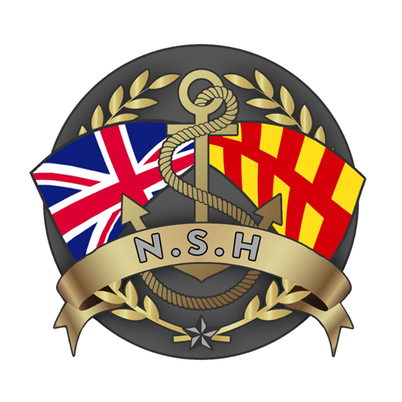
North Sunderland Harbour

Safety Management System

Section 15 – Complaints Procedure

Purpose of this Policy

The purpose of this policy is to ensure any complaints regarding a service provided or actions taken by any part of the North Sunderland Harbour are handled quickly, effectively and courteously and to swiftly resolve any issues, where possible.

Making a Complaint

Any customer of the Port (or someone acting on their behalf) who has received, or was entitled to receive, a service may make a complaint.

Additionally, any Stakeholder, defined as anyone who uses or is connected to the Port or whose livelihood and welfare may be dependent on the Port and all bodies who represent others in this context, may make a complaint.

North Sunderland Harbour Commissioner’s mission is to build the port’s prosperity and we aim to do this by delivering port infrastructure and services with energy and excellence.

Operational excellence is mandatory, and excellent customer service is key to achieving our objectives. However, sometimes things can occasionally go wrong.

If you are unhappy with the service you have received, or if our activities have negatively impacted on you as a stakeholder, then please let us know. It is important that we know what’s gone wrong, so that we can try to put it right.

This complaints policy sets out a clear process for anyone wishing to make a complaint and outlines what North Sunderland Harbour will do with any complaint received.

What is a Complaint?

A complaint is an expression of dissatisfaction requiring a response, communicated electronically or in writing. Complaints may be made by any users of our service and by any of our stakeholders. Examples might include complaints about:

- the Port’s actions or lack of action,
- governance issues,
- a standard of service received, or
- issues arising from the Port’s activities.

What is not a Complaint?

A complaint is not an expression of a concern or an enquiry. A concern or enquiry is a problem raised that can be resolved / responded to straight away (normally within 2-3 working days). These are not reported as complaints and fall outside this complaints policy.
The Harbour staff will normally be able to resolve most issues themselves without the need to instigate a formal complaints process. These informal matters are not officially recorded as part of our complaints process.

The Complaints Process

A complaint should be made using the procedure outlined below, there are 4 stages:

Stage 1 – Formal

A formal complaint must be made in writing to the Harbour Master. The best method is to use the email address – Harbourmaster@nsh.co.uk or send a letter to
The Harbour Master
Harbour Road
SEAHOUSES
Northumberland
NE68 7RN
Your complaint will be acknowledged within 7 working days and the Harbour Master will normally get in contact quickly to fully understand the nature of the complaint.

You will receive a written response from the Harbour Master within 28 days, setting out whether your complaint is considered to be justified and any remedial action to be taken.

What if I don’t agree with the outcome of the investigation?

If you are dissatisfied with the Harbour Masters response to your complaint, you can appeal by writing formally to the Chairman of the Harbour Commissioners. This is Stage 2 of the Port’s Complaints Process.

Stage 2 Appeal – Chairman

Please address your letter of appeal to:
The Chairman,
North Sunderland Harbour Commissioners,
Harbour Rd,
Seahouses,
NE68 7RN

Your complaint and appeal will be acknowledged by the Chairman within 7 working days.

The Chairman will form a view on the complaint and any further action to be taken and you will receive a written response outlining this within 28 days.

What if I still don’t agree with the outcome?

You can appeal against the decision made by the Chairman if you feel your complaint has not been handled sufficiently. This is stage 3 of the Port’s complaint process.

Stage 3 Appeal – Commissioners

An appeal must be made in writing to the full Board of North Sunderland Harbour Commissioners using the contact details above.

At the next Commissioners meeting, your complaint will be reviewed in detail by the full Board of 9 sitting Commissioners and the process will be overseen for impartiality by the Ports Designated Person. Neither the Chairman nor the Harbour Master will be involved in the Commissioner investigation.

The Commissioners will document, investigate, resolve (if possible) and respond, within 28 days of the meeting, to the complaint.

What if I am still dissatisfied or I don’t feel my complaint has been handled correctly?

If not satisfied with the response of the North Sunderland Commissioners, the only option left is to draw it to the attention of the Department for Transport (DfT). This is stage 4 of the Port’s complaint process.

Stage 4 – Department for Transport

Complaints to the DfT should be made in writing to:

Maladministration Complaints Department for Transport D/04,
Ashdown House,
Sedlescombe Road,
North St Leonards on Sea,
East Sussex,
TN37 7GA.

The DfT will then consider your complaint and decide whether to take the matter up with the Port itself. This is only likely to occur in what may appear to be particularly significant issues in relation to governance or, where the Port’s complaint handing process has been inadequate.

Where DfT decides not to follow a complaint up with the Port, it will write to the complainant setting out its reasons why.

Except in extreme cases, it is unlikely that the DfT will use its formal powers to take formal action against the Harbour Commissioners but it is likely to make strong recommendations in relation to any governance matter, and ensuring that the Port is governed properly and its Commissioners do not take decisions in an arbitrary or unaccountable manner.

This will be assessed using the direction set out in the Port Marine Safety Code (https://assets.publishing.service.gov.uk/media/5f63874d8fa8f51069100621/port-marine-safety-code.pdf) and the Ports Good Governance Guide. (https://assets.publishing.service.gov.uk/media/5f624ee08fa8f510664dc460/ports-good-governance-guidance.pdf)

