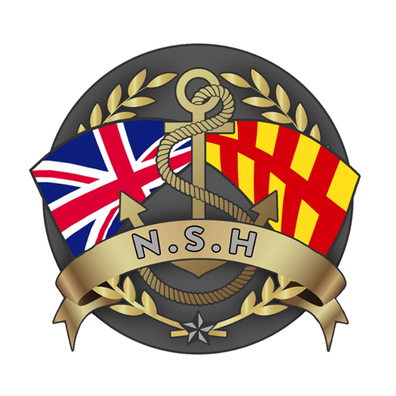
North Sunderland Harbour

Section 18 – Code of Conduct

CODE OF CONDUCT FOR HARBOUR USERS

Introduction
North Sunderland Harbour is a working harbour from which fishing and passenger vessels, dive boats, pleasure boats and the RNLI operate. It is situated in an area of outstanding natural beauty and is within easy reach of the Farne Islands, many bird and marine habitats and diving sites.

North Sunderland Harbour, often known as Seahouses, is managed by North Sunderland Harbour Commissioners. As a Trust Port, the Commissioners manage the Harbour for the benefit of users and the local community. Safety, efficient use of Harbour facilities, protection of the environment and balancing the interests of the different types of harbour users are the Commissioners’ key objectives.

Application
This Code of Conduct applies to all Harbour users: commercial and leisure. It does not replace or override the 2022 North Sunderland Harbour Bye-Laws, the North Sunderland Harbour Order (S.R.A.O. 1931/928) or any of the legislation that governs the use of ports and related maritime and environmental issues. As a Code of Conduct it does not have statutory force, but it sets out how the NSH Commissioners want the Harbour to be used and is endorsed by the NSH Harbour Users Group (HUG) which acts as the representative body of NSH Stakeholders.
Use of the harbour, its services and facilities, including berthing, mooring and launching facilities is subject to users complying with this Code.

Updates
The Commissioners expect the Code will develop over time, and the Commissioners welcome feedback on the Code through the HUG and will update it as necessary. The master copy of the Code is available on the Commissioner’s website.
Fiona Kibby
Harbour Master
Harbour Office, Harbour Road, SEAHOUSES, Northumberland, NE68 7RN
01665 720033 | 07867 685784 | harbourmaster@nsh.org.uk

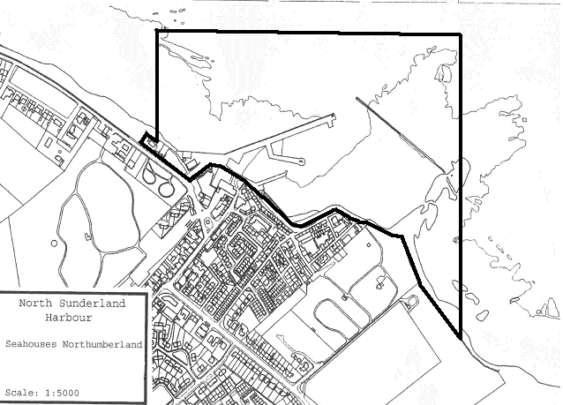
Image: NSH Statutory Harbour Authority area

NOTICES Notices to Mariners (NTMs) are displayed at the Harbour Office and on the Commissioner's website:www.nsh.org.uk and sent by email. NTMs and other directions from the Harbour Master, may temporarily override the contents of this Code.

COMMUNICATIONS

- The Harbour uses and monitors VHF Channel 8 during working hours.
- The Harbour Master can be contacted on:
Tel: 01665 720033 Mobile: 07867 685784
Email: harbourmaster@nsh.org.uk
- When underway in the harbour all commercial vessels shall keep watch on VHF Channel 16 and Channel 8.

HARBOUR DUES & OTHER CHARGES
- The Commissioners must charge for the use of the Harbour and for services / facilities provided. The Commissioners review the charges annually.
- Details of the current schedule of charges is available at the Harbour Office and on the website.
- Commercial fishing vessels are charged landing dues on their catch.
- Passenger vessels pay a licence fee to carry out passenger trips per season.

EMERGENCIES & RNLI

- The RNLI launches its Shannon and D class lifeboats from the Slipway.
- To do this the RNLI must have instant and unblocked access along Harbour Road from the station and onto the Slipway.

LAUNCHING & RECOVERY

- Use of the Slipway is subject to the Harbour Master's approval, which must be obtained before use.
- In adverse weather, the Harbour Master may close the Slipway or may regulate or prioritise its use.
- Commercial vessels may, with the Harbour Master's consent, use the Slipway for launching, hauling out and for emergency repairs of short duration.
- RIBs may be hauled out during bad weather with the prior consent of the Harbour Master.
- Commercial vessels, including charter boats, must not operate from the Slipway or use it to load/discharge goods or to embark/disembark passengers.
- The Slipway is not be used for storage of vessels or equipment.

NAVIGATION

- All vessels must comply with the Collision Regulations, exercise good seamanship and navigate with consideration for other Harbour users and the protection of the environment.
- The speed limit inside the Harbour is 3 knots.
- Small craft must give way to larger vessels that may be constrained by their draft and restricted in their ability to manoeuvre when using the channel from the Pier-End to the Outer Breakwater to enter or depart from the Harbour.
- All vessels must be manned by sufficient and competent crew each holding the necessary certificates.
- Lights, including lasers, must not be used within the Harbour limits, whether afloat or ashore, that may impede safe navigation or cause confusion with navigation lights.
- Under the Railways and Transport Act 1983, it is an offence to operate a vessel whilst under the influence of alcohol or drugs:
- The Master of any vessel involved in a collision, grounding, fire or other incident must immediately report the incident to the Harbour Master.
- The Master of any vessel using the Harbour whose safety or seaworthiness is compromised must (A) notify the Harbour Master and (B) not use the vessel until the problem has been rectified.
- In restricted visibility, it is recommended that no more than 1 vessel is under way inside the breakwaters at a time. Master do vessel are expected to coordinate this between themselves.

ANCHORING

- Except in emergency, anchoring within the harbour breakwaters is prohibited.
- Except in emergency, no vessel shall anchor outside the breakwaters "so as to impede traffic within the Harbour".

BERTHING - GENERAL

- "All vessels coming into the Harbour are subject to the control of the Harbour Master as to the place for mooring." Bye-Law 3.
- It is a condition of berthing in the Harbour that vessels comply with this Code of Conduct.
- Public landing places must not be obstructed.
- Mooring lines must not restrict the ability of other vessels to berth or navigate within the Harbour.
- Vessels coming to, berthed at, or leaving the quays must use fenders, to the satisfaction of the Harbour Master. Bye-Law 13.
- Vessels may be required to permit and assist other vessels to berth outboard.
- An inboard vessels must facilitate and if necessary, assist the crew of outboard vessels to access their vessel to/from the pier.

BERTHING - INNER HARBOUR

- The Commissioners make the Inner Harbour available for the berthing of commercial vessels, subject to available space. Berths are usually allocated on an annual basis.
- Berthing is subject to a berthing licence and payment of the prescribed charges.

BERTHING - RIBs

- RIBs are not normally permitted to berth in the Inner Harbour.
- The Harbour Master will normally allocate an Outer Harbour berth or pontoon berth to a RIB subject to space.

PASSENGER EMBARKATION & DISEMBARKATION
- Passengers must only embark/disembark from the Long Pier-End Steps, pontoon or from the steps on the Inner Harbour Slipway.
- No vessel may remain alongside the Pier-End Steps and Inner harbour Steps unless actually embarking or disembarking passengers or goods.
- Unless otherwise ordered by the Harbour Master, vessels shall queue for access to the Pier-End Steps in the order of their arrival in the vicinity of the steps.
- Leisure craft shall normally give priority to commercial vessels.
- Any vessel that wishes to remain alongside the pontoon for an extended period must have the Harbour Master’s permission.

LEISURE CRAFT
- Leisure craft must register at the Harbour Office prior to day launching and pay the appropriate fee.
- Leisure craft will be issued with a registry board for the day, which must be clearly displayed on the craft at all times.
- The owners of leisure craft must produce if requested, a valid certificate of insurance, which includes third-party liability cover on terms that a prudent owner of such a craft would consider appropriate in the circumstances.
- No water-skiing, paragliding, kite surfing, windsurfing and the use of personal watercraft ("Jetskis" and similar craft) is permitted in the Harbour.
- Powered leisure craft must use "kill cords" at all times when underway.
- The commercial landing of shellfish from leisure craft launched from the slipway is prohibited.
- Leisure craft are permitted to use the Outer Harbour, including the Pier-End Steps or pontoon for embarkation and disembarkation of passengers and loading and unloading of goods.

