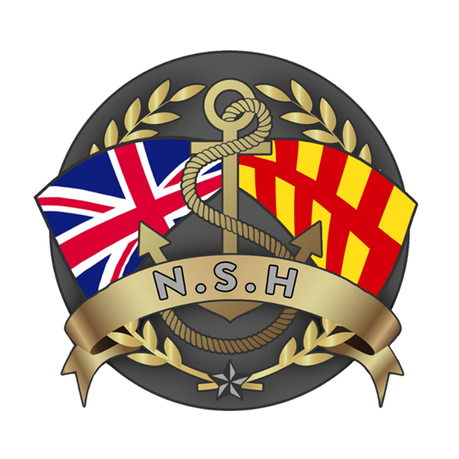
North Sunderland Harbour

Section 20

Port Master Plan 2025 -2035

Introduction

- The UK Department for Transport issued “Guidance on the Preparation of Port Master Plans” in 2008. This document states that while it is not mandatory for smaller ports to produce a Master Plan, it recognises the utility of such an exercise, particularly in helping port governing bodies in making longer term strategic and financial plans.

- This is not a Master Plan in the strictest sense of the word, this is the first iteration of the longer term financial and strategic plan for North Sunderland Harbour and will aim to cover the period 2025 to 2035.

- The intention is that, once this plan is agreed after the regulatory and stakeholder consultation process described below, the plan should be used by the North Sunderland Harbour Commissioners (NSHC) to allocate resources accordingly for its delivery.

- The plan should be updated by the NSHC every 2 years.

The Need
- The underlying business model for North Sunderland Harbour is unlikely to change in the foreseeable future.
- Marine traffic using the port will likely continue to be based on 3 streams of activity:
  - Fishing boats of 12m or less using pots or nets and daily landing their catch for local market consumption. It is envisaged that unless another strategic economic shock occurs (Brexit etc) there will likely be between 6-12 fishing boats using NSH as their base.
  - Tourist tripping boats of 24m or less taking passengers to the Farne Island and to Lindisfarne. It is felt unlikely that this traffic will expand much beyond present levels.
  - Small leisure vessels which are able to “dry out” in the tidal cycle.
- As a Trust Port, NSHC are required to make and deliver long terms plans to meet the anticipated needs of its users and stakeholders, while staying financially efficient.

The Process

- The first iteration of this plan was submitted, discussed and approved by the NSHC in July 2024.
- The updated plan was shared with the North Sunderland Harbour Users Group (HUG) for discussion and comment in September 2024.
- Other interested parties, such as local authorities, neighbouring ports and bodies such as IFCA may also be invited to separate comment in October 2024.
- In October 2024, the document will also be offered to the MCA Ports Division for comment.
- The final updated document will be resubmitted to the NSHC at the November 2024 meeting for approval.
- Update to the plan will be expected in July 2027.

What the Plan should Consider

- The plan should consider the following, non-exhaustive list of items:
  - The needs and requirements of shore infrastructure:
    - Buildings – glazing, roofs, weather protection.
    - Assets and equipment both existing and new e.g. cranes, fork lift, new equipment needs.
    - Energy – solar power?
    - Roads / Paths / Car Parks – resurfacing, relining.
    - Drains / tanks – replacing, relining, decommissioning.
    - IT / CCTV – printer, camera + computer upgrades, servers and on-going support.
    - Port signage – replacements.
    - Port lighting upgrade.

  - Long, Middle and Short Jetties:
    - Structural integrity – surveys, pointing and repairs.
    - Guard rails – servicing & replacement.
    - Wheel-stops – repairs.
    - Ladders / chains – replace / repair.
    - Bollards – load test and maintain.
    - Lifebuoys – update.
    - Aids to Navigation - maintain.
    - Cranes – maintain and replace.
  - The Slipway:
    - Structural integrity – surveys, pointing and repairs.
    - Access control.
  - Steps and Boarding Points:
    - Find a better, safer method for passenger embarkation.
    - All tide / more vessels.
  - Harbour Waters:
    - More efficient use of mooring in inner harbour.
    - Use the outer harbour – assess conditions.
    - Requirement for vessel deconfliction?
  - Fuels / Propulsion:
    - Provisions for electric / hydrogen / ammonia propulsion.
    - Supply of electric power.
    - Storage of other fuels.
  - Energy Security:
    - Consider solar power options.
    - Consider local wind power options.
  - Dredge / Hydrology:
    - Establish hydrology regime.
    - Deepen Inner and Outer Harbour.
    - Consider the Fluke.
  - Environment:
    - Harbour garbage disposal methods.
    - Waste oil tank – dispose.
    - Harbour water quality monitoring.
    - Harbour wildlife monitoring.
  - Global Warming:
    - Sea level rise – outer breakwater secure?
  - Leisure development:
    - Fluke Hole?
    - Visitors deep water options – buoys?
    - Landing Pontoons?
Retail Development

The Plan – Year By Year

- 2025
  - CCTV Server upgrade + cameras refurbish. - Completed
  - Completion of Pontoon installation - Completed
  - Dredge and deepen harbour. (Moved to Spring 2026)
  - Initiate Fluke Hole options study.
  - Port ladders / cranes survey - Completed
  - Garage survey.
  - Waste and recycling review.
  - Staff car parking allocate - Completed
- 2026
  - Waste Oil Tank – decommission.
  - Fuel tank – assessment/ replacement plan, review move to use of A2 class marine diesel.
  - Implement Harbour water quality and wildlife monitoring.
  - Inner harbour slipway steps redesign. include bump guard on slipway.
  - Port bollards survey.
  - Retail plan and Policy review.

- 2027.
  - Master Plan Update.
  - Forklift replacement / re-life.
  - Boat winter storage options revisit.
  - Global warming sea level assessment.
  - Port building energy assessments.

- 2028.
  - Jetties x 3 structural survey.
  - Port outside lighting upgrade.

- 2029.
  - Resurface car park + roads.

- 2030.
  - Guardrails structural survey

- 2031.

- 2032.

- 2033.

- 2034.

- 2035.

https://infrastructure.planninginspectorate.gov.uk/wp-content/ipc/uploads/projects/TR030001/TR030001-001984-121026_TR030001%20Port%20master%20plan%20guidance.pdf

