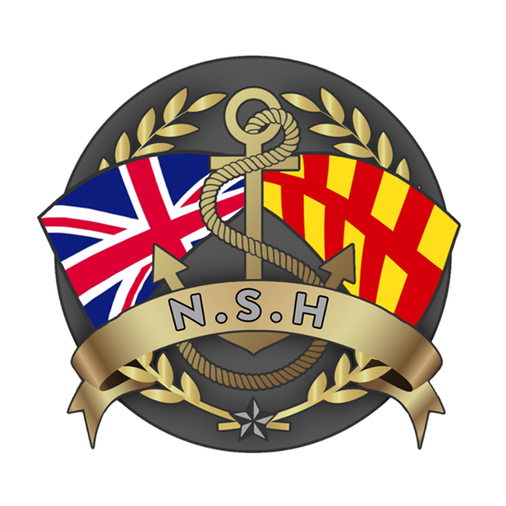

North Sunderland Harbour

Safety Management System

Section 3 – Aids to Navigation

Aids to Navigation

North Sunderland Harbour (NSH) is a Local Lighthouse Authority (LLA) and as such has a legally binding duty to monitor, maintain and report the availability of the Aids to Navigation (AtoNs) within the physical limits of the harbour to Trinity House, the General Lighthouse Authority (GLA) for England.

NSH has 3 Aids to Navigation, these are:

AtoN Number | Name | Type | Details
N06151 | Breakwater South End | Flashing Red 3 Seconds | Height 7m  Range
N06152 | Outer Pier End North West | Traffic Signal: Fixed Green (Go) or Fixed Red (Stop) | Height 7.6m  Range 5m
N07880 | Outer Pier End North West | Fog Signal | Siren 90S

The Outer Pier End Fixed Light (G or R) and the Breakwater South End lights are important navigational aids for users of NSH.

The active use of the Traffic Control element of the Fixed Green / Red lights appears to have fallen into disuse – (December 2023). The traffic control function, utility and future use of these lights will be reviewed in early 2024.

Survey of Aids to Navigation:

The correct functioning of all AtoNs is checked by NSH Harbour Staff on a monthly basis. This inspection is recorded and physically signed for on the AtoN Inspection Form attached below and held in the Harbour Office.

Every 6 months each of the AtoNs will be maintained (cleaned, greased etc) – this inspection also recorded on the AtoN Inspection Form below.

It is expected that Harbour users will also quickly report any AtoN failure to the Harbour Master.

An annual survey of all Aids to Navigation is carried out by the Trinity House Inspector of Seamarks – this normally happens in November or December each year.

Fault Reporting:

Any faults are to be reported to the Harbour Master who will record them using the Trinity House; Local Aids to Navigation Reporting System - LARS.
https://lars.trinityhouse.co.uk/

The NSH port registration number and login for this system is A4015. The website password for the NSH section of the Trinity House website is held by the HM and the Clerk.

If the defect is likely to persist for more than 24 hours, then a Local Notice to Mariners will be issued by the Harbour Master and placed on the NSH website.

Maintenance & Repair:

NSH AtoNs are classed as International Association of Lighthouse Authority (IALA) Category 3 lights and signals. This means that they must be available for 97% of the time.

In the event of a defect being identified, port staff will, in the first instance attempt to rectify it themselves or if they are unable to fix it, will call first, the Harbour Master and then either of the 2 electrical companies in Seahouses to assist.

Oswald Hughes Electricals – 01665 720344
Alan MacFarlane – 07904 686243

If these companies cannot assist, then the search for assistance will expand further afield noting the availability requirement of the AtoNs.

