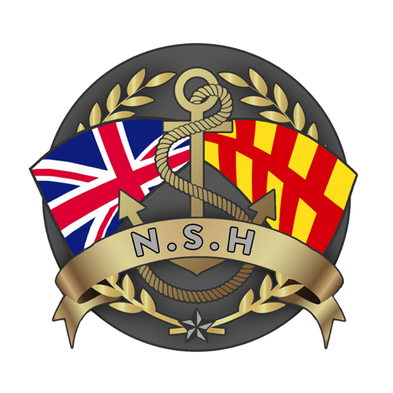

North Sunderland Harbour

Safety Management System

Section 4 – Conservancy & Dredging

Introduction

This document sets out the policy that North Sunderland Harbour Commissioners wish to be adopted to govern the conduct of hydrography, port surveys and dredging in the port.

Along with the rest of the SMS, it will be reviewed annually by the Harbour Master and will need to be reapproved by the Commissioners in the event of significant changes.

Hydrography

Every port needs a baseline of hydrographic surveys to establish trends and to identify areas in the port that require dredging attention.

It is a basic function of a Statutory Harbour Authority to maintain the safety of navigation within its port area.

In order for this to be achieved, a full port hydrographic sonar survey will be conducted in 2025 and every 3 years thereafter to establish silting and scouring trends and to enable meaningful comparisons with historical survey data.

The content of these surveys will then be communicated to the Hydrographic Office and to port users.

Dredging:

Section 31(1) of the 1931 North Sunderland Harbour Act empowers the Harbour Authority to dredge, remove and sell the dredged materials from within the Statutory Harbour Authority Area – provided that permission to do so has been granted by the Marine Management Organisation (MMO)(as was the Board of Trade).

The 1931 Act empowers the Harbour Authority to “dredge, scour and excavate any portion of the foreshore and the bed of the sea necessary to secure a sufficient waterway” in order to keep the channel and the port open.

Understanding trends in siltation or scouring from the hydrographic surveys will allow the Harbour Master to establish the requirement for dredging in the harbour and its approaches.

If a dredge campaign were deemed necessary, the Harbour Master will first be required to explain the requirement for approval and funding by the Commissioners.

