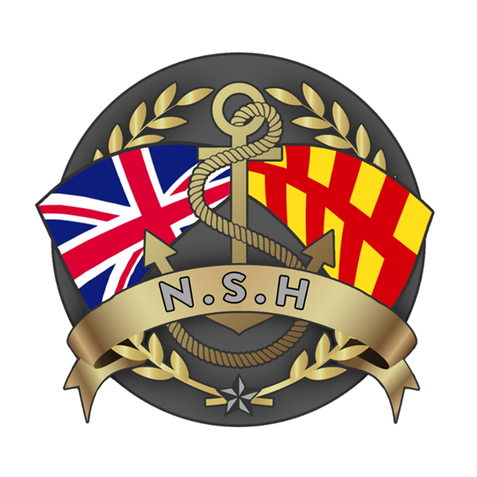
North Sunderland Harbour

Safety Management System

Section 5 – Anchorages

Anchorages

There are no routine anchorages within the limits of the North Sunderland Harbour or its approaches.
Ships waiting orders or seeking shelter will occasionally lie off the port.
NSH will normally exercise no control over vessels anchoring off the port and any anchorages are used entirely at the vessel Masters discretion.

Emergency Anchorages

In the event of any emergency during entry or exit from the port it is possible for vessels to drop anchor/s anywhere within the port limits but only as much or as long as is required to stabilise the emergency.

Moorings

The allocation and regulation of moorings and alongside berths in NSH are addressed in the Commissioners Berthing Agreement which is Section 13 of the Safety Management System.

