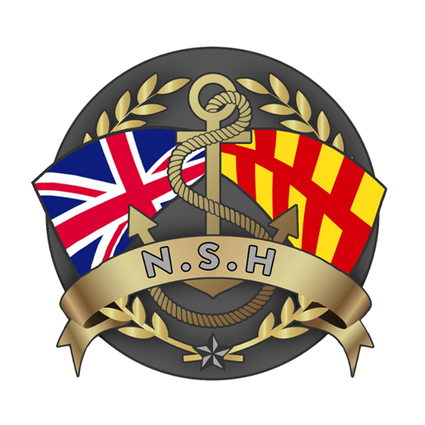
North Sunderland Harbour

Safety Management System

Section 6 – Pilotage

Pilotage:

Assessing the need:

The Port Marine Safety Code and the Pilotage Act 1988 requires all Harbour Authorities to assess the need for pilotage within their Statutory Harbour Authority area and to periodically review this need.

In North Sunderland Harbour (Seahouses), the last pilotage review was conducted on 25th June 2025 and the North Sunderland Harbour Commissioners after consultation, hazard identification and formal risk assessment concluded that the provision of a pilotage service is not required for North Sunderland Harbour.

