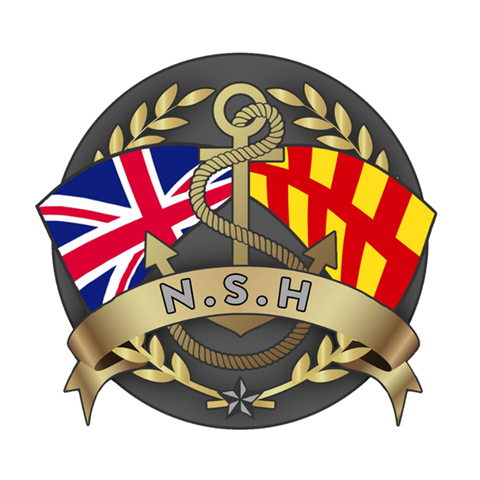
North Sunderland Harbour

Safety Management System

Section 7 – Bunkering and Pollution Prevention

References:
- NSH Oil Spill Response Plan.
- NSH Risk Assessments.

Introduction:

There are 2 fixed facilities in North Sunderland Harbour which fall under “Bunkering and Pollution Prevention.”
The first is the commercial bunkering facility at the Middle Pier and the second is the Waste Oil Storage Tank (WOST) in the car parking area at the head of the Long Pier. Commercial petrol or Heavy Fuel Oil is not available at NSH.

Commercial Bunkering – Middle Pier:

- The commercial bunkering facility at the end of Middle Pier is owned and operated by NSH.

- The bunker tank holds 40,000 litres of Marine Gas Oil (Red Diesel) and was installed in 1997 by NSH for the benefit of the commercial fishing and trip boat operators using and operating from NSH.

- The tank was installed by Taylor Fuel Control in August and September 1997 and is inspected and certified by Industrial Services, Contact Industrial Services in Scotland.

- The tank is protected by Armco traffic collision barriers and sits in a weather protective structure.

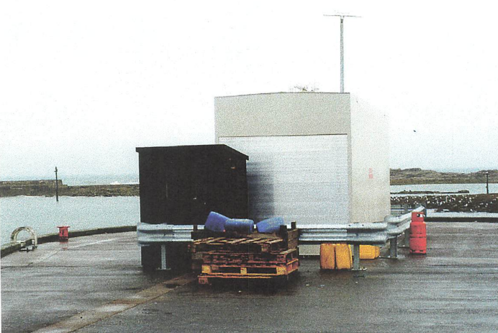

- The tank is filled by Chrystal Petroleum or Johnson Oils Ltd of Alnwick, Northumberland. Replacement fuel is ordered by the Clerk, Kay Barkess.

Bunkering Operation:

- Vessels wishing to come alongside the bunkering berths do so on an ad hoc arrangement and withdraw fuel using their allocated key. A list of the keyholders is held within the harbour office.

- Vessel crews are trained by NSH staff in the safe operation of the fuelling facility and only those persons having been trained are permitted to use it. A record of the trained persons is held in the Harbour Office.

- There are 2 hoses capable of fuelling 2 vessel moored either side of the Middle Pier.

- Billing for MGO taken is done by NSH on an issued invoice basis.

- Supervision and daily / weekly inspections of the bunker facility is done by NSH harbour staff.
- The bunkering facility is also under continuous CCTV camera surveillance.

- Firefighting equipment kept next to the bunker tank is listed below, it is maintained and inspected monthly by NSH staff. The nearest fire hydrant is at: Harbour Road between the Harbour office and the slipway access. There is also one located outside The Olde Ship Inn on the Harbour hill.

- Tier 1 oil spill containment equipment is kept in a container next to the bunker tank – this is checked every month by NSH staff.

Waste Oil Storage Tank (WOST):

- The WOST is owned and operated by NSH, it is located by the sea wall opposite the RNLI station. Its location is shown at Figure 1 below:

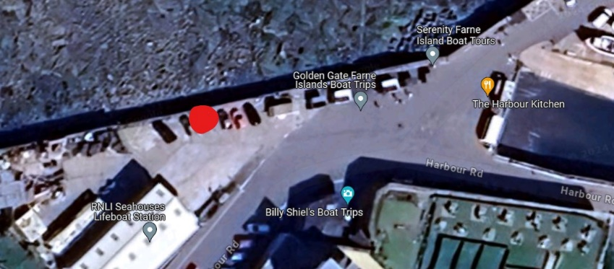

Figure 1 - Waste Oil Tank Location - NSH

- The WOST was installed by Alan Hogg in September 2006 and is inspected and certified by XXX Ltd every XX years.

- The next inspection and certification of the tank is due in XXXX. The requirement for a replacement bunded tank compliant with modern standards will be assessed in Q2 2024.

- The WOST holds 2,700 litres of waste oil and was installed for the benefit of the commercial fishing and trip boat operators using and operating from NSH.

- The tank level is measured at XXXX by NSH every fortnight. Emptying of the tank is ordered by NSH staff and it is normally undertaken by Oil Monster Ltd of Teeside depot.

- Access to the deposit waste oils in the tank is controlled by NSH. Before being cleared for use of the tank, NSH deliver training in accordance with XXX standards. A record of the training and the names of authorised person to use the tank is here XXX.

Marine Pollution Response Plan

To satisfy the requirements of the Oil Pollution Preparedness Response and Co-operation Convention Regs (the OPRC Regs), the North Sunderland Harbour has implemented a Marine Pollution Response Plan. The plan is held at the Harbour Office and on the Harbour Website.

The Marine Pollution Response Plan details the Port’s obligations in the event of a pollution incident. This includes the procedures to be followed, the equipment available, the assistance available, reporting requirements, subsequent clean-up process, environmental issues and training required.

All oil spills into Harbour waters must be reported immediately to the Harbour Master, who will in turn activate the necessary response as described in the Marine Pollution Response Plan.

The Harbour Master may detain a vessel if he has reason to believe that it has committed an offence by discharging oil into Harbour waters. The Harbour Master also has the power to board a vessel to investigate possible offences.

North Sunderland Harbour have a programme of Oil Spill Exercises that is dictated by the Oil Spill Response plan.

