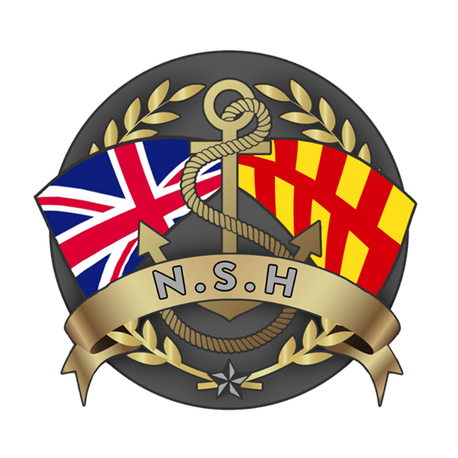
North Sunderland Harbour

Safety Management System

Section 8 – Towage

Towage Provision Review

The Harbour Master will conduct a bi-annual review in order to determine the numbers, availability, types and capacities of marine towage that might be required to service North Sunderland Harbour; this will always take into account the size and manoeuvring capability of vessels expected to call.

The last towage review was conducted on 25th June 2025 and concluded that given the size and type of vessels entering the Port, the use of tugs was not compulsory or required.

Towage Services

Any towage that might be undertaken in the Port would be subject to the United Kingdom Standard Conditions for Towage and Other Services (Revised 1986).

The Need for Towage

The decision whether or not to ask for tug assistance to berth/unberth a vessel rests primarily with the Master of the vessel and because of scarce availability of assets, would need to be discussed with the Harbour Master long in advance of the vessel’s arrival.

Any towage that might take place would likely be in support of specific construction or towing project and would be subject to its own risk assessment to determine the level of towage provision.

