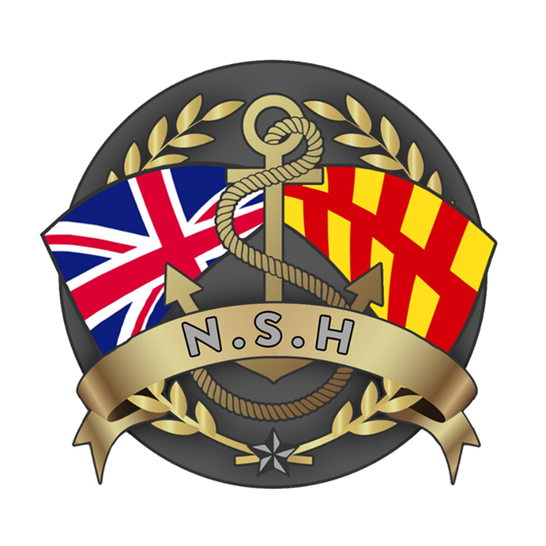
North Sunderland Harbour

Safety Management System

Section 9 – Abandoned Vessels and Wrecks

Introduction

This document records the method for North Sunderland Harbour Authority to identify and remove abandoned vessels and wrecks from the port.

The April 2022 British Ports Association guidance on dealing with abandoned vessels in Harbours should be read in conjunction with this policy.
https://www.britishports.org.uk/content/uploads/2022/07/Abandoned-Vessels-Guidance-1.0.pdf

Legal Background

The Harbour, Docks and Piers Clauses Act 1847, Section 56 and 57 states:

Section 56. Wrecks and Obstructions:
“The Harbour Master may remove any wreck or other obstruction to the harbour, dock, or pier, or the approaches to the same, and also any floating timber which impedes the navigation thereof, and the expense of removing any such wreck, obstruction, or floating timber shall be repaid by the owner of the same; and the Harbour Master may detain such wreck or floating timber for securing the expenses, and on nonpayment of such expenses, on demand, may sell such wreck or floating timber, and out of the proceeds of such sale pay such expenses, rendering the overplus, if any, to the owner on demand.”

Section 57. Unserviceable Vessels to be Altogether Removed from Harbour:
“No vessel which shall be laid by or neglected as unfit for sea service shall be permitted to lie within the limits of the harbour, dock, or pier, but the harbour master may cause every such vessel to be, at the expense of the owner thereof, removed from the harbour, dock, or pier, and laid on any part of the strand or sea shore, or other place where the same may, without injury to any person, be placed; and the charges of removing or placing such vessel may be recovered from the owner of such vessel by summary complaint, in England or Ireland before any justice of the peace, and in Scotland before the sheriff; and in case of refusal or neglect of payment of such charges for the space of seven days after having been awarded by such justice or sheriff, the harbour master may levy such charges by distress and sale of such vessel, or of the tackle, apparel, or furniture thereof, or any part thereof, and the justice or sheriff shall issue his warrant accordingly.”

The Port Marine Safety Code
The PMSC also considers wrecks and abandoned vessels in paragraphs 4.25 and 4.26:

Para 4.25:
“Where there is a wreck in, or near, the approaches to a harbour which is or is likely to become a danger to navigation the harbour authority may take possession of, remove or destroy it. They may mark the location of the wreck until it is raised, removed or destroyed (in accordance with Section 252 of the Merchant Shipping Act 1995).”

Para 4.26:
Harbour authorities must exercise their wreck-marking and removal powers where, in their opinion, a wreck is – or is likely to become – an obstruction or danger to navigation. They have a duty to have regard to the environment in the exercise of this and all other duties and powers.”

North Sunderland Harbour Abandoned Vessel and Wreck Policy

- North Sunderland Harbour Authority will aim to remove from the Statutory Harbour Authority area any vessel which is classed as being abandoned or wrecked within a period of three months from the time that it is established that the vessel is truly abandoned or beyond repair.”

- The identification and demarcation of a vessel as being abandoned or wrecked is a notoriously legally complicated process and North Sunderland Harbour Authority has no wish to engage in long, complicated and expensive battles in order to ensure that every vessel in the port is fully serviceable and visually acceptable.

- Nevertheless, the harbour authority has a binding duty to maintain the safety of navigation within the port and that includes ensuring that each vessel therein is safe, fit for the purpose it was designed for and able to withstand the structural rigors presented by the sea and river.

- Even if a vessel in the port may never realistically be expected to proceed to the open sea, they still have to adhere to certain national or international safety standards; if not sea going safety standards, then at the very least those expected for vessels on inlands waterways.

- If there are vessels which are clearly never going to be able to meet that safety standard, then the Harbour is required and expected to take action to remove them. The process below describes how North Sunderland Harbour Authority will proceed to identify wrecked of abandoned vessels.

Abandoned or Wrecked Vessel Procedure

- When a vessel is either reported or suspected as being wrecked or abandoned the following procedure will be followed:
  - A documented inquiry will begin to establish who was the last registered owner and or who is the current owner.
  - Pictures of the vessel will be posted on the North Sunderland Harbour Website to assist in tracing the owner.
  - Letter and emails will be written to the last known address.
  - A “Please contact the Harbour Master” sticker will be placed on the vessel where it can best be seen.

If the Owner is Identified:

- A written formal contact will be made with the owner by the Harbour Master to establish their intentions for the vessel and if possible, to agree a binding plan and timescale for the repair of the vessel.

- The vessel owner will be asked to supply written proof of the “fitness of the vessel for sea service” within the meaning of section 57 of the Harbour, Docks and Piers Clauses Act 1847. This would be expected to include but not be limited to:

  - Proof of Insurance covering the fitness of the vessel for its intended purpose”
  - The vessels registration and structural integrity survey.
  - The vessels MCA Coding or Boat Safety Scheme Certification as appropriate.
  - Evidence that sufficient personal safety equipment is carried on board.
  - Evidence that the vessel has left the berth under its own power within the last 6 months.
  - Evidence that the vessel is being maintained.
  - OR written agreement from the Harbour Authority for the vessel to be non-seaworthy while an agreed schedule of repairs is conducted.

- If the owner cannot supply proof of, or a reasonable timescale to meet, the requirements set out in paragraph 3 within 1 month of being contacted, then the vessel will be classified as a wreck and will be removed by the Harbour Authority at the owner’s expense.

- The Harbour Authority may employ an independent MCA approved vessel survey company to endorse the “wreck” classification at the owner’s expense.

If No Owner Is Found:

- After one month of the picture being posted on the Harbour Authority website, the vessel will then be classified as an abandoned vessel and the Harbour Master will cause an Abandoned Vessel Notice to be placed on the vessel giving 14 days’ notice for removal.

- If no one has claimed ownership after 14 days, the vessel will be removed by North Sunderland Harbour and it will either be destroyed or advertised for sale, depending upon its condition.

- A record of correspondence and the condition of the vessel will be kept, including photographs and an independent survey if required.

- The decision as to whether a vessel will be destroyed is taken by Harbour Master following an assessment of condition, risk and viability for sale.

- The Harbour Board will be updated at each meeting regarding the number of wrecked and abandoned vessels within the Statutory Harbour Authority area and their progress through the disposal procedure.

Sea Going Wrecks

- In the event of an incident occurring within the Harbour Authority limits which results in a sea going vessel becoming classed as a wreck, the following procedure will be followed to ensure the continued safety of navigation.

  - An initial Dynamic Risk Assessment will be carried out to determine the extent of the hazard presented to other vessels navigating in the area. This will include identifying the vessel name, owner, type of vessel, the precise location, any ancillary equipment such as nets or ropes attached to vessel, possible environmental impact and pollution risks.
  - A report must be made to the Receiver of Wrecks through the MCA. (See MCA website).
  - The position of the wreck will be marked by the appropriate IALA buoys as soon as practicable. If parts of the wreck are still visible above water, consideration will be given to attaching lights to the wreck.
  - A “Local Notice to Mariners” will be issued.
  - A detailed Risk Assessment will be carried out to assess the severity of the hazard to navigation and to determine what action is required as regards salvage etc.
  - The Risk Assessment will include a survey of the wreck site (e.g. By Single or Multi Beam Echo Sounders).
  - Harbour Authorities are empowered by legislation (e.g. 1847 Harbour, Docks & Piers Act, 1995 Merchant Shipping Act, Section 252) to remove wrecks which impede navigation.
  - Section 6.6.5 of the Guide to Good Practice on Port Marine Operations gives clear advice on the processes to be considered before any salvage work commences. This includes informing the MCA if the salvage operation is associated with a significant risk of pollution.
  - If salvage of the wreck is found to be impractical, then arrangements will be made to permanently mark the wreck.

The Boat Safety Scheme, or BSS, is a public safety initiative owned equally by the Canal & River Trust and the Environment Agency. Its purpose is to help minimise the risk of boat fires, explosions, or pollution. https://www.boatsafetyscheme.org/

